**Ayinde Feranmi**

**Project Summary:**

This Tableau visualization project is designed to provide a comprehensive analysis of the impact of COVID-19 across the nation. Utilizing official health data, the dashboard compares several crucial metrics: active COVID-19 cases, the number of deaths, the percentage of the population affected, and recovery rates. Each metric is visualized through dynamic charts and graphs that allow for easy comparison over time and across different regions within the country.

**Dashboard 1**

**Data Story:**

This dashboard presents data on COVID-19 active cases and deaths in five countries—Russia, the UK, the USA, India, and Brazil, as of the end of December 2021. The USA has the highest number of active cases, followed by the UK. Russia, India, and Brazil have relatively fewer active cases compared to the USA and the UK. The USA shows the highest number of deaths, with a significant margin over the other countries. India and Brazil also show substantial numbers of deaths, though less than the USA. The UK and Russia have the lowest number of deaths among the five countries.

**Dashboard 2**

**Data Story:**

This dashboard provides information on COVID-19 testing and new cases for five countries: Brazil, the UK, the USA, Russia, and India as of August 15, 2021. The USA shows the highest number of tests conducted, followed by India and the UK. Russia and Brazil have conducted fewer tests compared to the USA, India, and the UK. The line chart indicates a significant difference in testing volumes among these countries, with the USA leading substantially. The pie chart shows that the USA and India have the highest number of daily new cases. Brazil, Russia, and the UK have relatively fewer new cases compared to the USA and India. The proportion of new cases in each country reflects the current state of the pandemic on August 15, 2021.

**Dashboard 3**

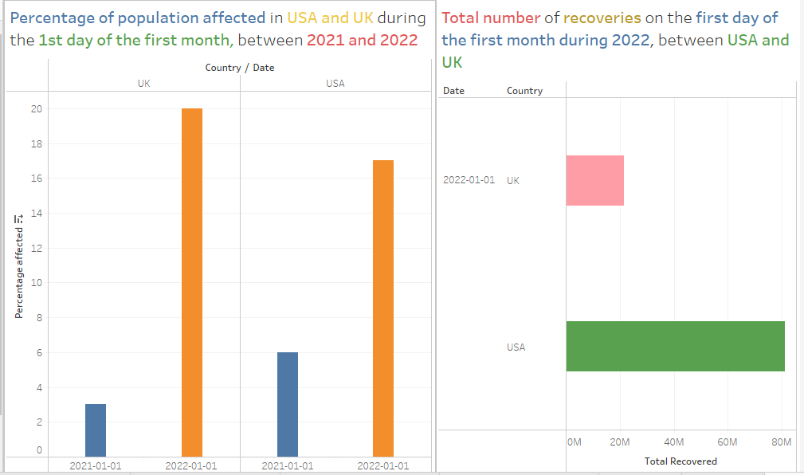

**Data Story:**

This dashboard provides insights into the COVID-19 situation in the USA and the UK, focusing on the percentage of the population affected and the number of recoveries during specific periods in 2021 and 2022.  In 2021, the UK had a higher percentage of its population affected compared to the USA. In 2022, both the USA and the UK show an increase in the percentage of the population affected, with the USA showing a significant rise. The UK, while still showing an increase from 2021 to 2022, has a lower increase rate compared to the USA. The USA had a significantly higher number of recoveries compared to the UK as of January 1, 2022. The difference in recoveries between the two countries is substantial, with the USA leading by a considerable margin.

**Final data story including dashboards 1, 2, and 3:**

The three dashboards collectively narrate the progression and impact of the COVID-19 pandemic across the USA, the UK, Russia, India, and Brazil, with a particular emphasis on the USA and the UK. The first dashboard illustrates the severe impact on the USA, leading in both active cases and deaths as of December 2021, underscoring the need for robust healthcare interventions. In contrast, Russia and Brazil report lower figures, indicating different pandemic reporting standards. The second dashboard, focusing on August 2021, emphasizes extensive testing efforts in the USA and India, correlating high testing volumes with substantial new cases. Despite high testing, the UK reports fewer new cases, suggesting effective public health measures, while Russia and Brazil show lower testing and new case numbers. The third dashboard highlights the evolving scenario into 2022, with both the USA and the UK showing increases in the percentage of the population affected, the USA experiencing a sharper rise. The USA also records a significantly higher number of recoveries compared to the UK, reflecting both higher transmission rates and recovery efforts. Collectively, these dashboards reveal the dynamic and complex nature of the pandemic, highlighting differences in public health responses, healthcare capacity, and the ongoing challenges each country faces in managing the crisis.

**Link to Dataset:**

<https://docs.google.com/spreadsheets/d/13qyfuZjtpfnXkpuquUfuZ-Q4CIWkDhoK/edit?gid=961260466#gid=961260466>

**Link to Tableau Public:**

<https://public.tableau.com/app/profile/feranmi.ayinde/viz/Fer_Ayi_project2_info4709/Dashboard1#1>